Q1

TITLE My First Program (Test.asm)

INCLUDE Irvine32.inc

.data

val1 SDWORD 8000h

.code

main PROC

mov eax,0

mov eax, val1

add eax, 1

call DumpRegs

exit

main ENDP

END main

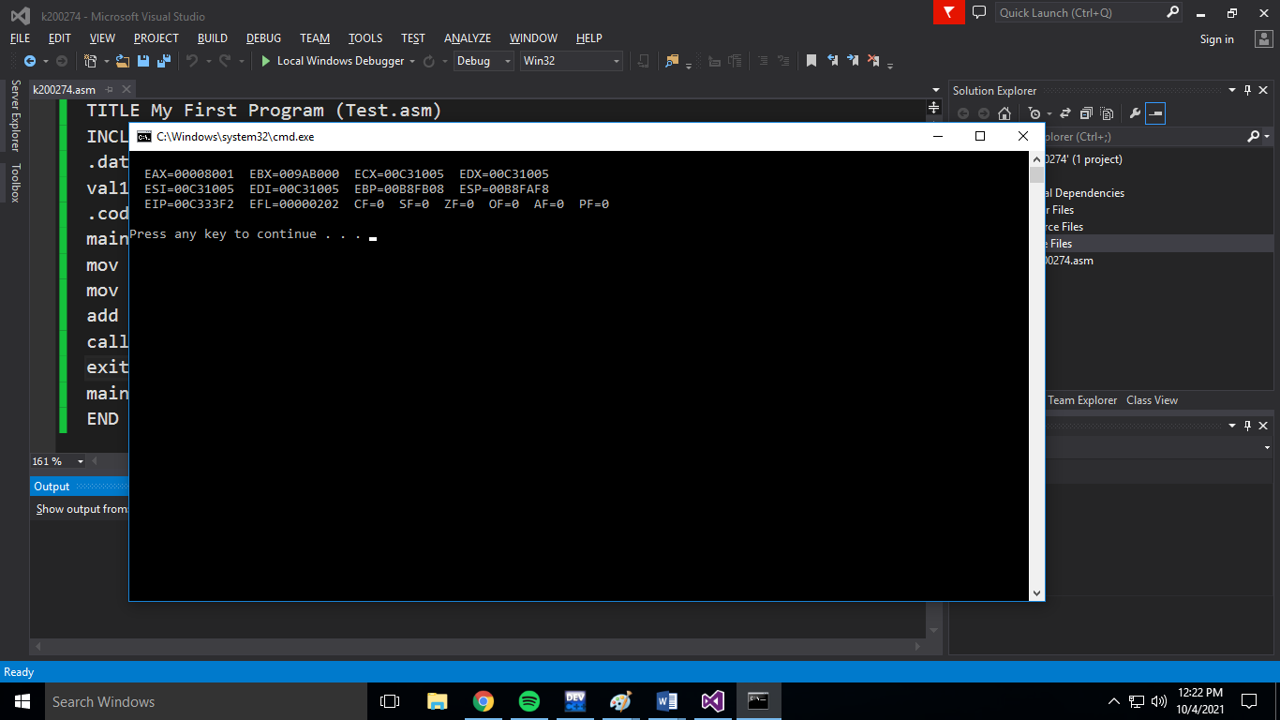

Q2)a

TITLE My First Program (Test.asm)

INCLUDE Irvine32.inc

.data

.code

main PROC

mov eax,0

mov ax,7FF0h

call DumpRegs

exit

main ENDP

END main

1. CF=0 SF=0 ZF=1 OF=0

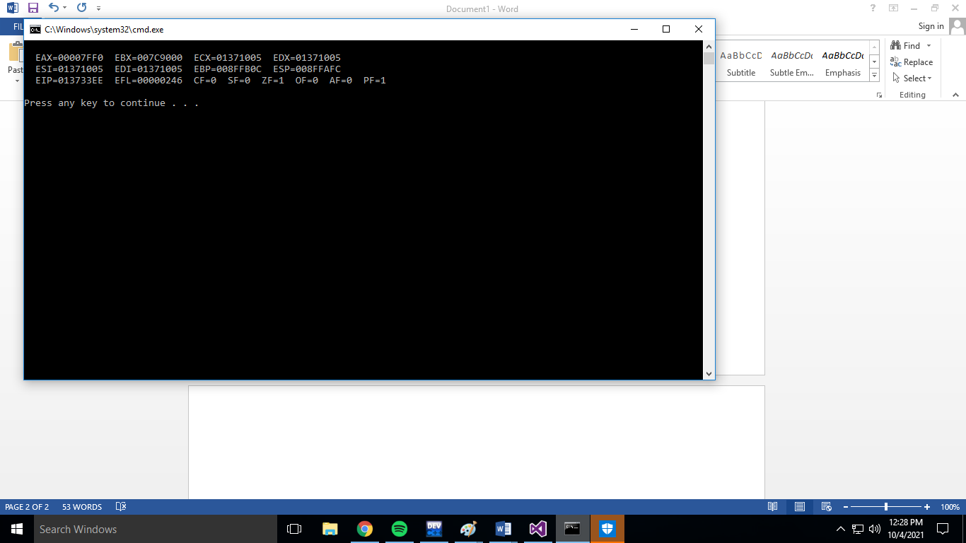

b)

TITLE My First Program (Test.asm)

INCLUDE Irvine32.inc

.data

.code

main PROC

mov eax,0

mov ax,7FF0h

add al,10h

call DumpRegs

exit

main ENDP

END main

b) CF=1 SF=0 ZF=1 OF=0

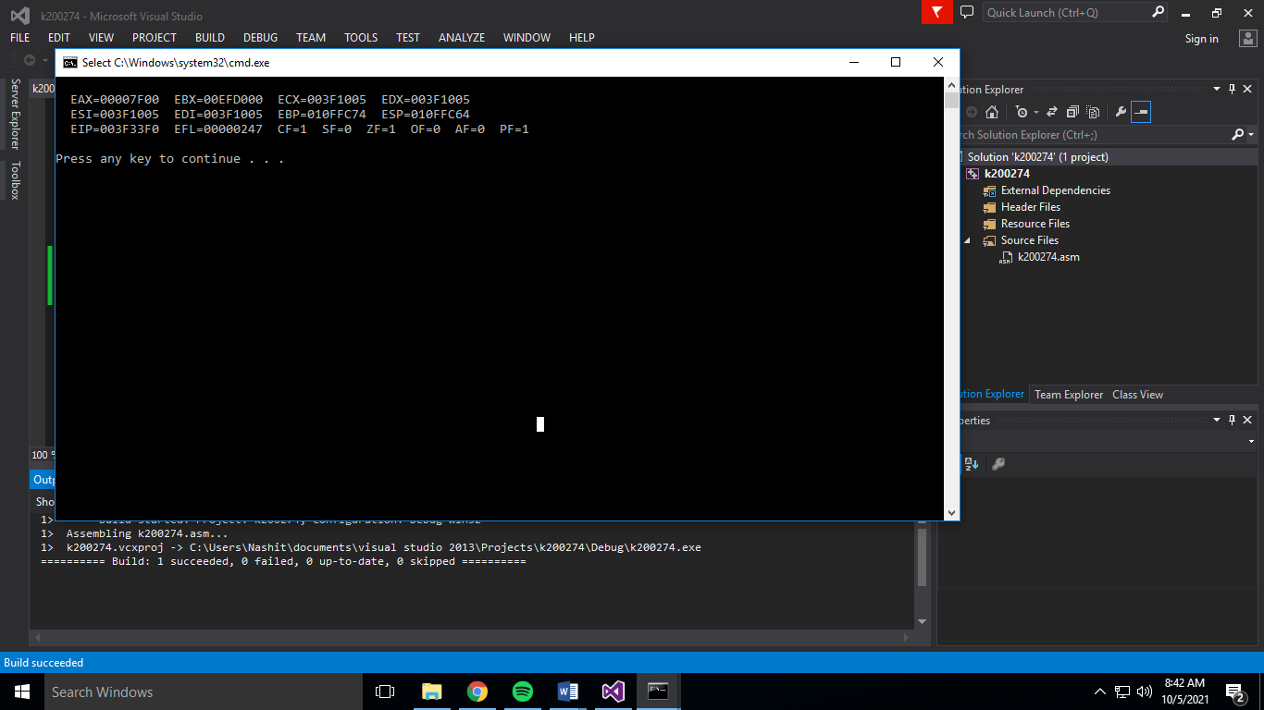

C)

TITLE My First Program (Test.asm)

INCLUDE Irvine32.inc

.data

.code

main PROC

mov eax,0

mov ax,7FF0h

add al,10h

add ah,1

call DumpRegs

exit

main ENDP

END main

c)CF=0 SF=1 ZF=0 OF=1

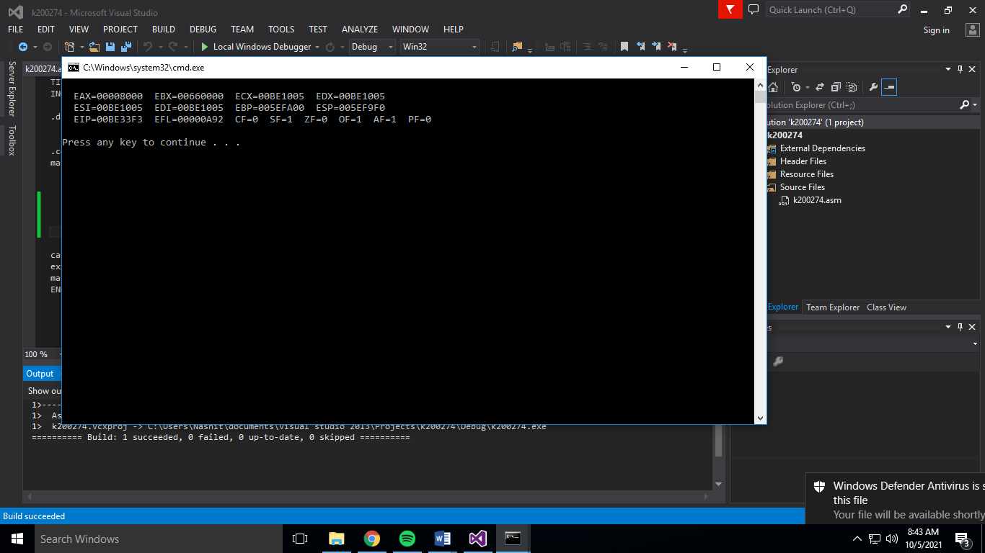

d)

TITLE My First Program (Test.asm)

INCLUDE Irvine32.inc

.data

.code

main PROC

mov eax,0

mov ax,7FF0h

add al,10h

add ah,1

add ax,2

call DumpRegs

exit

main ENDP

END main

d)CF=0 SF=1 ZF=0 OF=0

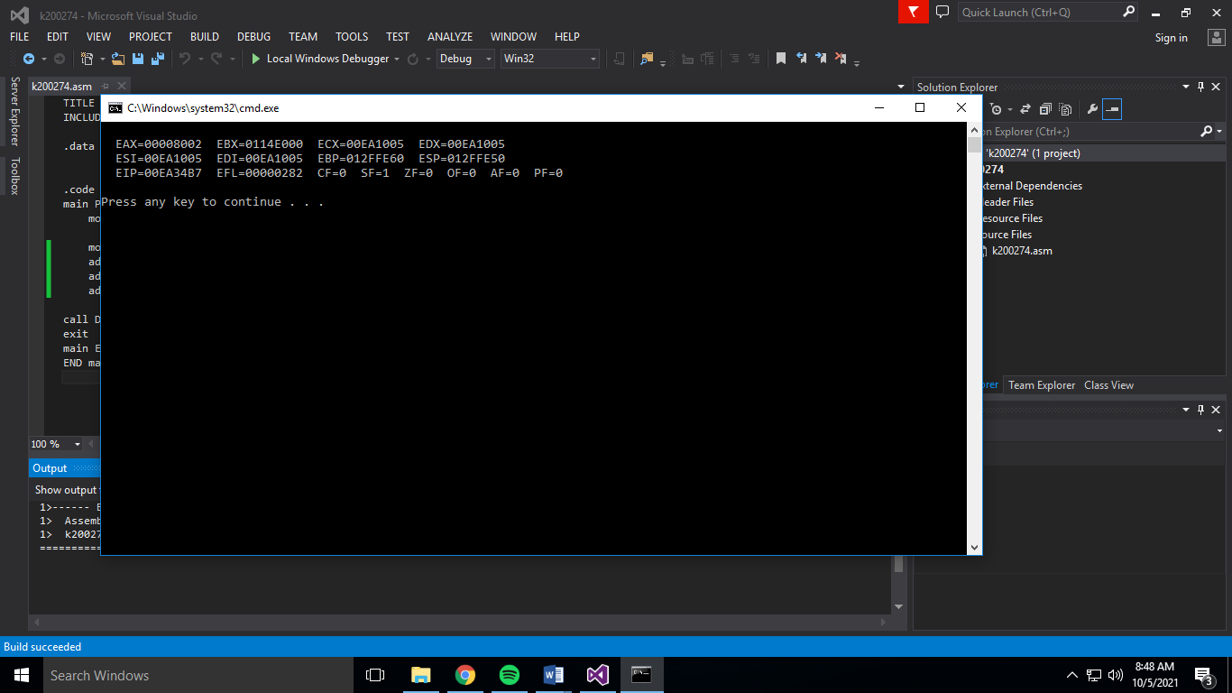

Q3)

TITLE My First Program (Test.asm)

INCLUDE Irvine32.inc

.data

array BYTE 61h,43h,11h,52h,25h

sarray BYTE 0,0,0,0,0

.code

main PROC

mov eax, 0

mov al, array[2]

mov sarray[0],al

mov al, array[4]

mov sarray[1],al

mov al, array[1]

mov sarray[2], al

mov al, array[3]

mov sarray[3],al

mov al, array[0]

mov sarray[4],al

mov ebx,0

mov ecx,0

mov edx,0

mov ah, sarray[0]

mov al, sarray[1]

mov bh, sarray[2]

mov bl, sarray[3]

mov ch, sarray[4]

call DumpRegs

exit

main ENDP

END main

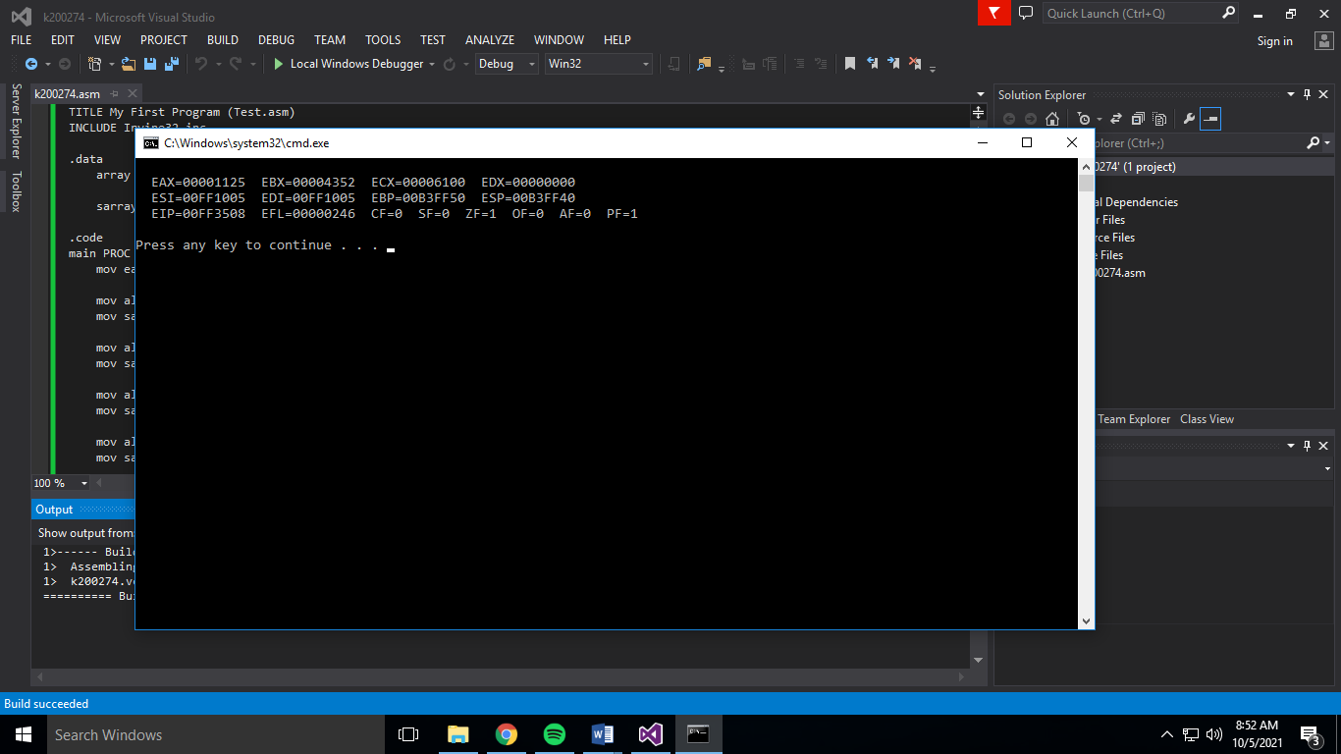

Q4)

TITLE My First Program (Test.asm)

INCLUDE Irvine32.inc

.data

arrayB BYTE 10h,20h,30h

arrayW WORD 150h,0250h,350h

arrayD DWORD 600h,1200h,1800h

sum1 DWORD ?

sum2 DWORD ?

sum3 DWORD ?

.code

main PROC

mov eax,0

mov ebx,0

mov ecx,0

mov edx,0

movzx eax, arrayB[0]

movzx ebx, arrayW[0]

add eax,ebx

add eax, arrayD[0]

mov sum1, eax

mov eax,0

mov ebx,0

movzx eax, arrayB[1]

movzx ebx, arrayW[2]

add eax,ebx

add eax, arrayD[4]

mov sum2, eax

mov eax,0

mov ebx,0

movzx eax, arrayB[2]

movzx ebx, arrayW[4]

add eax,ebx

add eax, arrayD[8]

mov sum3, eax

mov eax,0

mov ebx,0

mov eax,sum1

mov ebx,sum2

mov ecx,sum3

call DumpRegs

exit

main ENDP

END main

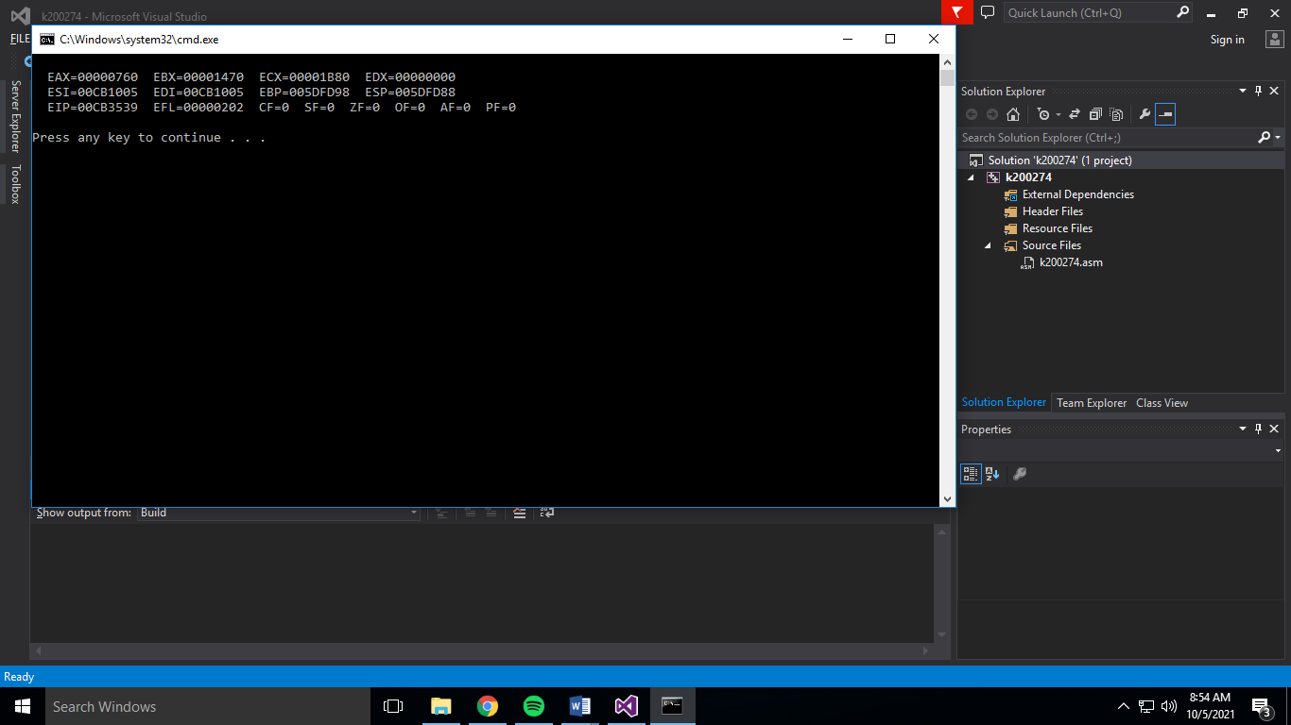

Q5)

TITLE My First Program (Test.asm)

INCLUDE Irvine32.inc

.data

arr BYTE 10h,20h,30h,40h

array2 BYTE 4 DUP (?)

.code

main PROC

mov eax,0

mov ebx,0

mov ecx,0

mov edx,0

mov al, [arr+3]

mov bl, [arr+2]

mov cl, [arr+1]

mov dl, [arr+0]

mov array2[0],dl

mov array2[1],cl

mov array2[2],bl

mov array2[3],al

call DumpRegs

exit

main ENDP

END main

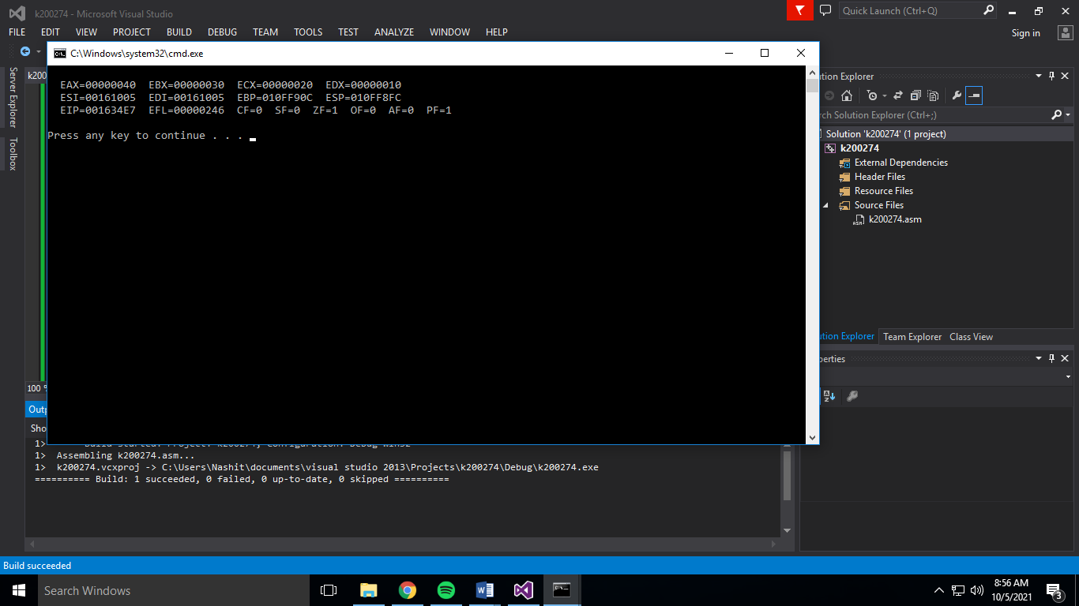

Q6)

TITLE My First Program (Test.asm)

INCLUDE Irvine32.inc

.data

arr DWORD 1200h,1120h,1130h,1140h

.code

main PROC

mov eax,0

mov ebx,0

mov ecx,0

mov edx,0

mov esi, OFFSET arr

mov eax, [esi]

dec eax

add esi, 4

mov ebx, [esi]

dec ebx

add esi, 4

mov ecx, [esi]

dec ecx

add esi, 4

mov edx, [esi]

dec edx

call DumpRegs

exit

main ENDP

END main

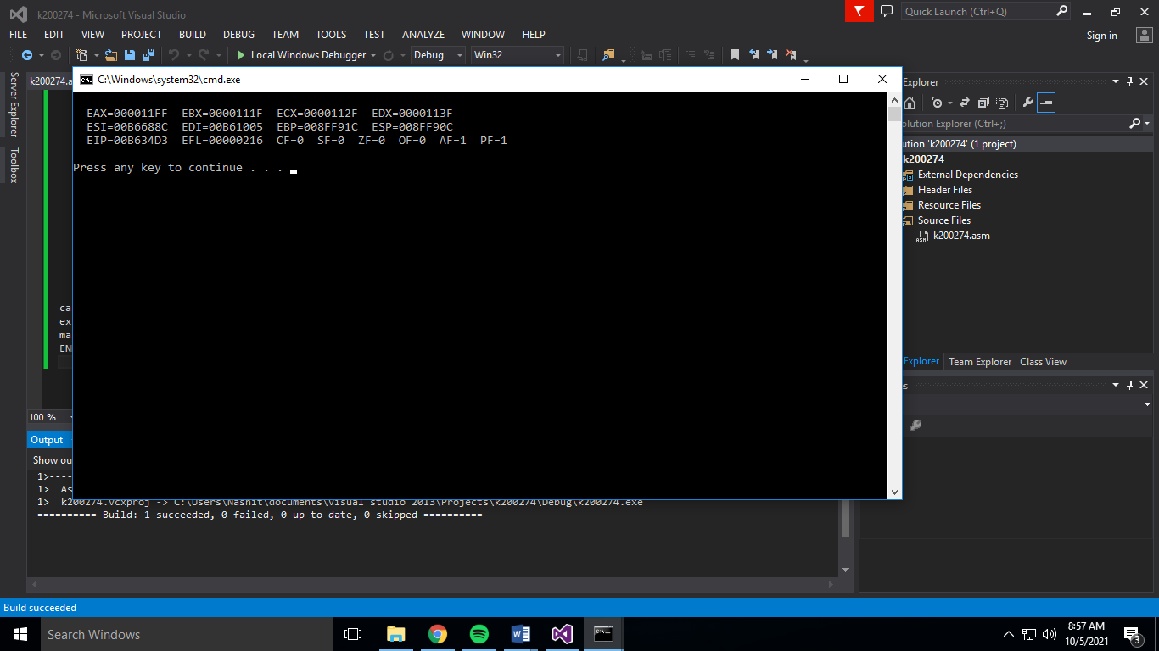

Q7)

TITLE My First Program (Test.asm)

INCLUDE Irvine32.inc

.data

arrayB BYTE 10h,20h,30h

arrayW WORD 150h,0250h,350h

arrayD DWORD 600h,1200h,1800h

.code

main PROC

mov eax,0

mov ebx,0

mov ecx,0

mov esi,0

mov al, arrayB[esi \* TYPE arrayB]

add esi,2

mov bl, arrayB[esi \* TYPE arrayB]

add al,bl

mov ebx,0

mov ecx,0

mov esi,0

mov bx, arrayW[esi \* TYPE arrayW]

add esi,2

mov cx, arrayW[esi \* TYPE arrayW]

add bx,cx

mov ecx,0

mov edx,0

mov esi,0

mov ecx, arrayD[esi \* TYPE arrayD]

add esi,2

mov edx, arrayD[esi \* TYPE arrayD]

add cx,dx

call DumpRegs

exit

main ENDP

END main

